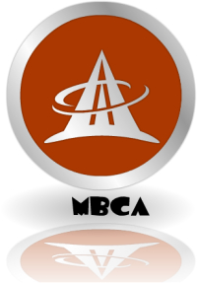 **Monterey Bay Chinese Association (MBCA)**

**蒙特雷华人协会2022年烧烤大会**

**MBCA BBQ Party 2022**

July 4, 2022 (Monday) 12PM – 4PM 2022/7/4，下午12-4点

Location/地点： Whispering Primes Park

185 Pacific St., Monterey, CA 93940

The park can accommodate 80 people maximum. Please sign up by sending email to [yuemeng@yahoo.com](mailto:yuemeng@yahoo.com), [zhenl9@hotmail.com](mailto:zhenl9@hotmail.com), or [dannilu467@gmail.com](mailto:dannilu467@gmail.com). You can also send text message to 831-224-0583.

Deadline for signing up: June 28, 2022 登记截止日期 2022/6/28

The event is free for MBCA members and friends.华协会员和朋友免费

All participants are suggested, not required, to wear masks.

By participating in this BBQ event, each participant will assume all risks, and covenant not to sue or hold Monterey Bay Chinese Association or its respective members and volunteers responsible for any personal health issues or injury, or loss / damage to their property resulting from their participation, including loss related to Covid-19.